

NAME:

MUHAMMAD MUDASSIR RAZA CLASS:

BSCS (3-A) SUBJECT:

DATABASE MANAGEMENT SYSTEM

TEACHER:

MISS SANA QABIL

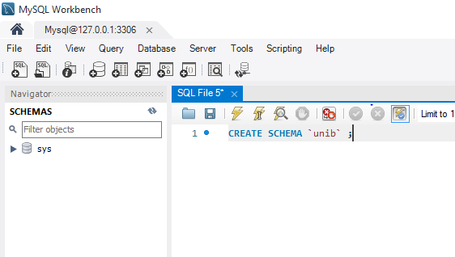

1. Write a CREATE TABLE statement for the Customer table. Choose data types appropriate for the DBMS used in your course. All columns are required (not null).

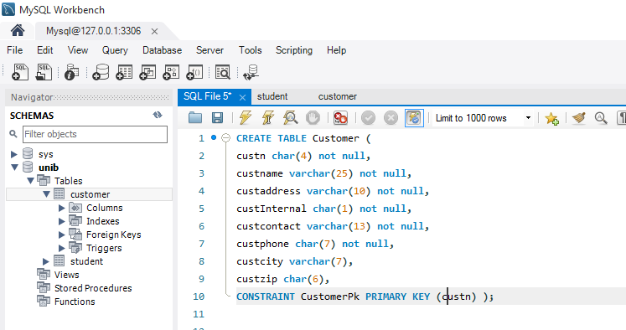

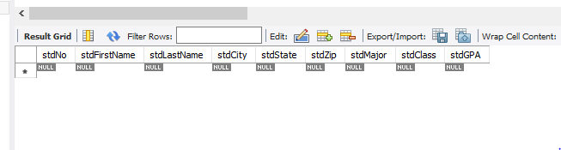

2. Write a CREATE TABLE statement for the Facility table. Choose data types appropriate for the DBMS used in your course. All columns are required (not null).

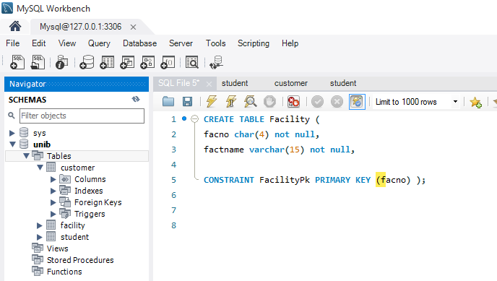

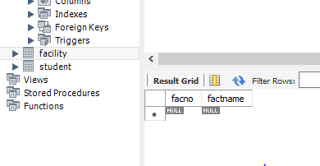

3. Write a CREATE TABLE statement for the Location table. Choose data types appropriate for the DBMS used in your course. LocName column is required (not null).



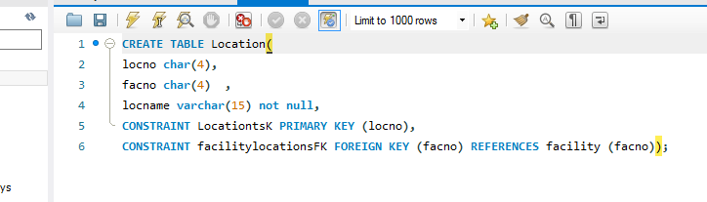

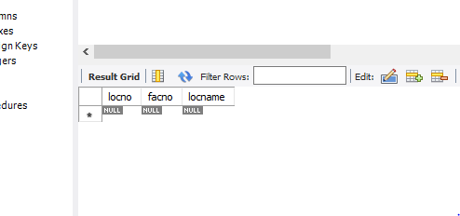

4. Identify the foreign key(s) and 1-M relationship(s) among the Customer, Facility, and Location tables. For each relationship, identify the parent table and the child table.

The Foreign Key is facno and one to many relationship between Facility and Location. Parent table is Facility and child table is Location.

5. Extend your CREATE TABLE statement from problem (3) with referential integrity constraints.

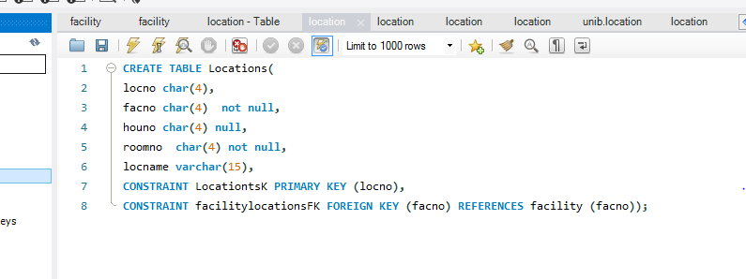

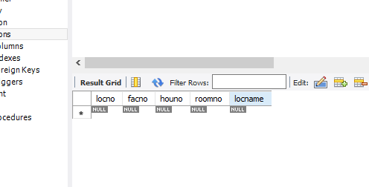

6. From examination of the sample data and your common understanding of scheduling and operation of events, are null values allowed for the foreign key in the Location table? Why or why not? Extend the CREATE TABLE statement in problem (5) to enforce the null value restrictions if any.

No, null values are not allowed for the foreign key in the location table

because foreign key of location table is primary key in facility table

and primary key never be null.

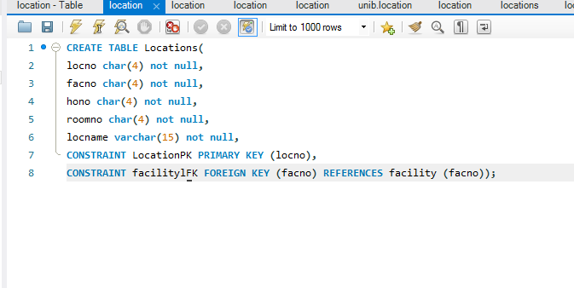

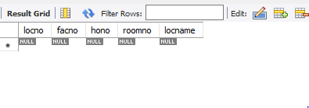

7. Extend your CREATE TABLE statement for the Facility table (problem 2) with a unique constraint for FacName. Use an external named constraint clause for the unique constraint.

